New website of the Krško Nuclear Power Plant
New modern and interacitve website of the Krško Nuclear Power Plant offers its users up-to-date basic information about the company's management, mission, values and commitments, as well as about the NPP's technological features and key operational results. Website is launched in three languages: Slovenian, Croatian and English.
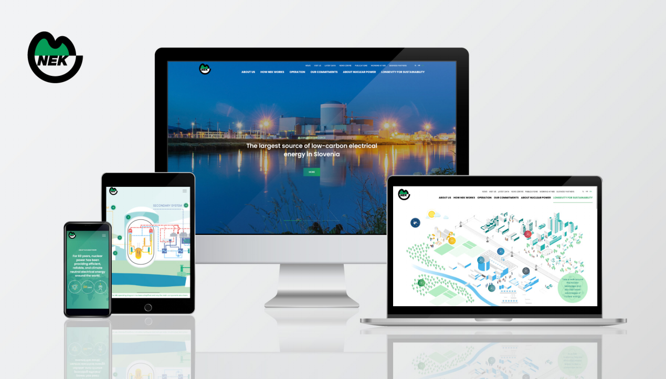
In addition to the corporate part of the web presentation, the website has huge potential for education and awareness-raising about nuclear energy and its role in modern society:
- Firstly, it offers a science-based educational overview of the basics of nuclear energy, the nuclear fuel cycle and the nuclear power plant operations (see the section titled About Nuclear Power: About nuclear power | Krško Nuclear Power Plant (nek.si)

- Secondly, it is accompanied by an interactive visualisation of the nuclear landscape where the web user can explore the broader social, environmental, climate, technical/technological and economic aspects of nuclear power (see the section titled Longevity for Sustainability: Longevity for Sustainability | Krško Nuclear Power Plant (nek.si)). The information in this section is based on a diverse set of Slovenian, European and international information sources, including (but not limited to) IEA, IAEA, OECD NEA, ENS and several others. The web user is invited to take a digital walk-through the graphically presented nuclear landscape, decide on her/his topic of interest and then enjoy the bite-sized information on a range of topics, related to the longevity and sustainability of nuclear power. Alternatively, the user can explore the same bites of information about the advantages of nuclear energy through an interactive prism of selected UN's Sustainable Development Goals.
With this advanced and convincing digital nuclear communications approach, the Krško NPP's website is planned to be of interest to the broadest group of stakeholders, including the educational community and the citizens who are interested in energy issues and are looking for information about the nuclear power's realistic contribution to the achievement of climate neutrality and other sustainable development goals.

